





a) Run Gibbs sampling and approximate the posterior distribution. The code is copied in attachment. Results are stored in variable “THETA” and “SMT”. Check convergence, we know the result is acceptable. Use post-burn-in values for following calculations.

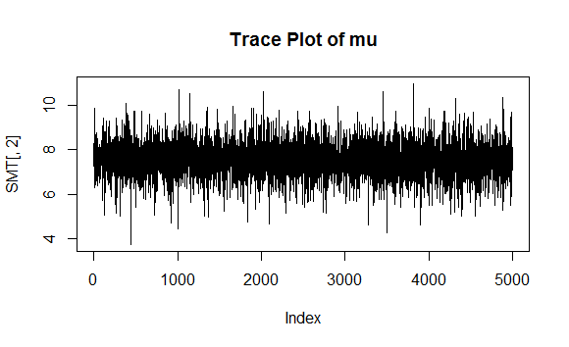

b)

|  |  |  |  |
| --- | --- | --- | --- |
|  | Prior | Posterior Mean | 95% Confidence Interval |
| σ^2 | 1.816596 | 1.803604 | (1.672684, 1.941098) |
| μ | 7.262718 | 7.567186 | (5.983655, 9.081597) |
| τ^2 | 5.445397 | 5.661819 | (2.077722, 14.510708) |

Comparisons between the densities are drawn out below:

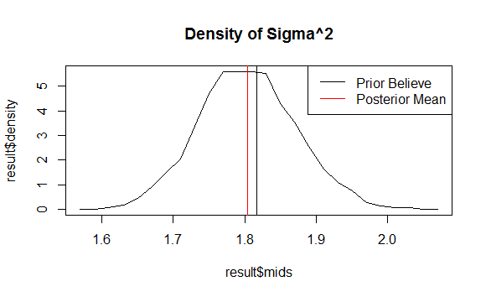

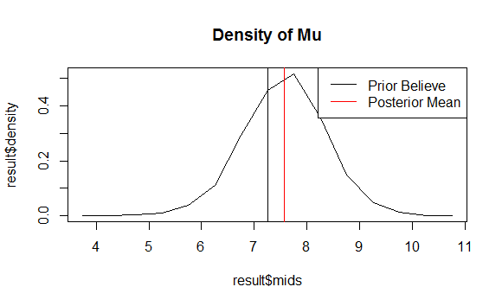

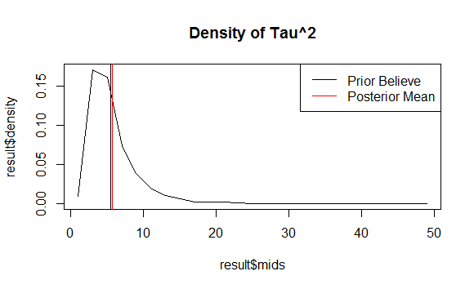

Comparing the densities we can see that the posterior mean is not very far away from our prior belief about the data. The sampling gave us more confident of the area where those variables may fall in.

3) The posterior density of R is plotted below with comparison of prior.

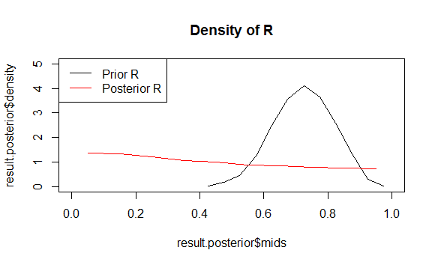

|  |  |  |
| --- | --- | --- |
|  | Mean | 95% Confidence Interval |
| Prior R | 0.4350736 | (0.0178848, 0.9631193) |
| Posterior R | 0.7221168 | (0.5347478, 0.8896042) |

The posterior belief in R shows that “between school variance tau^2” is actually bigger and more dominant than the “within school variance sigma^2”, which resulted in that over 95% R >0.5.

d) The probability is calculated using the result from Gibbs sampling, whose code is attached.

|  |  |
| --- | --- |
|  | Probability |
| θ7< θ6 | 65.56% |
| θ7< All other θ | 54.12% |

e) Data and posterior mean is shown in the below table and plotted as well. We can tell that the difference between data mean and posterior mean is pretty small, as a result of a weakly informative prior.

|  |  |  |  |  |  |  |  |  |
| --- | --- | --- | --- | --- | --- | --- | --- | --- |
| School | 1 | 2 | 3 | 4 | 5 | 6 | 7 | 8 |
| Data | 9.464000 | 7.033478 | 7.953000 | 6.232083 | 10.765833 | 6.205000 | 6.132727 | 7.381000 |
| Posterior | 9.462212 | 7.033666 | 7.950210 | 6.232945 | 10.761551 | 6.207202 | 6.140305 | 7.380687 |

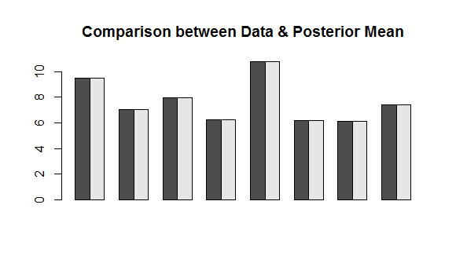

The comparison between all sample data mean and posterior mean of mu is shown in the below table, we can see that the posterior gives lower mean than the data. The reason for this is because in the data, there are more schools lower than the average and they dominate the posterior estimate of mu.

|  |  |
| --- | --- |
| All Data Mean | 7.646097 |
| Posterior Mean of mu | 7.262718 |

###CODE

library(mvtnorm)

#data

m=8

Y<-matrix(ncol=m)

Y[1] <- read.table("http://www.stat.washington.edu/hoff/Book/Data/hwdata/school1.dat")

Y[2] <- read.table("http://www.stat.washington.edu/hoff/Book/Data/hwdata/school2.dat")

Y[3] <- read.table("http://www.stat.washington.edu/hoff/Book/Data/hwdata/school3.dat")

Y[4] <- read.table("http://www.stat.washington.edu/hoff/Book/Data/hwdata/school4.dat")

Y[5] <- read.table("http://www.stat.washington.edu/hoff/Book/Data/hwdata/school5.dat")

Y[6] <- read.table("http://www.stat.washington.edu/hoff/Book/Data/hwdata/school6.dat")

Y[7] <- read.table("http://www.stat.washington.edu/hoff/Book/Data/hwdata/school7.dat")

Y[8] <- read.table("http://www.stat.washington.edu/hoff/Book/Data/hwdata/school8.dat")

#as.matrix(as.data.frame())

#X<-matrix(nrow=25,ncol=m)

##weakly informative priors

nu0<-2 ; s20<-15

eta0<-2 ; t20<-10

mu0<-7 ; g20<-5

### initials

n<-sv<-ybar<-rep(NA,m)

for ( j in 1:m)

{

y<-unlist(Y[j])

ybar[j] <- mean(y)

sv[j] <- var(y)

n[j] <- sum(y)

}

theta <- ybar ; sigma2 <- mean(sv)

mu <- mean(theta) ; tau2 <-var(theta)

#########GIBBS#######

set.seed(1)

S<-5000

THETA<-matrix(nrow=S , ncol=m)

SMT<-matrix(nrow=S , ncol=3)

###

for ( s in 1:S)

{

#sample a new value of mu

vmu<- 1/(m/tau2+1/g20 )

emu<- vmu*(m*mean(theta)/tau2 + mu0/g20 )

mu<-rnorm( 1,emu,sqrt(vmu))

#sample a new value of tau2

etam<- eta0+m

ss<- eta0*t20 + sum( (theta-mu)^2 )

tau2<- 1/rgamma ( 1 , etam/2 , ss/2)

#sample new values of the thetas

for (j in 1:m)

{

vtheta <- 1/(n[j]/sigma2+1/tau2 )

etheta <- vtheta*( ybar[j] * n[j]/sigma2+mu/tau2 )

theta[j] <- rnorm( 1 , etheta , sqrt(vtheta))

}

#sample new value of sigma2

nun<- nu0+sum(n)

ss<- nu0*s20

for ( j in 1 :m)

{

y=unlist(Y[j])

ss<-ss+sum((y - theta[j])^2)

}

sigma2 <- 1/rgamma ( 1,nun/2,ss/2)

#store results

THETA[s,]<-theta

SMT[s,]<-c(sigma2,mu,tau2)

}

plot(SMT[,2],type="l",main='Trace Plot of mu')

##########sigma

mean(SMT[,1])

quantile(SMT[,1],c(0.025,0.975))

result<-hist(SMT[,1],breaks=20,plot="false")

plot(result$mids,result$density,type="l",main="Density of Sigma^2")

abline(v=sigma2,col=1)

abline(v=mean(SMT[,1]),col=2)

legend("topright", legend=c("Prior Believe","Posterior Mean"),lty=c(1,1),col=c(1,2))

###### mu

mean(SMT[,2])

quantile(SMT[,2],c(0.025,0.975))

result<-hist(SMT[,2],breaks=20,plot="false")

plot(result$mids,result$density,type="l",main="Density of Mu")

abline(v=mu,col=1)

abline(v=mean(SMT[,2]),col=2)

legend("topright", legend=c("Prior Believe","Posterior Mean"),lty=c(1,1),col=c(1,2))

###### tau2

mean(SMT[,3])

quantile(SMT[,3],c(0.025,0.975))

result<-hist(SMT[,3],breaks=20,plot="false")

plot(result$mids,result$density,type="l",main="Density of Tau^2")

abline(v=tau2,col=1)

abline(v=mean(SMT[,3]),col=2)

legend("topright", legend=c("Prior Believe","Posterior Mean"),lty=c(1,1),col=c(1,2))

# Question 3

#posterior

R=SMT[,3]/(SMT[,1]+SMT[,3])

mean(R)

quantile(R,c(0.025,0.975))

result.posterior<-hist(R,plot="false")

#prior

tau2.prior<-1/rgamma(5000,eta0/2,eta0*t20/2)

sigma2.prior<-1/rgamma(5000,nu0/2,nu0*s20/2)

R.prior=tau2.prior/(sigma2.prior+tau2.prior)

mean(R.prior)

quantile(R.prior,c(0.025,0.975))

result.prior<-hist(R.prior,plot="false")

plot(result.posterior$mids,result.posterior$density,type="l",main="Density of R",xlim=c(0,1),ylim=c(0,5))

lines(result.prior$mids,result.prior$density,type="l",col=2)

legend("topleft", legend=c("Prior R","Posterior R"),lty=c(1,1),col=c(1,2))

######### Problem 4

####4.1

count=0

for ( s in 1:S)

{

if (THETA[s,7]<THETA[s,6]) count=count+1

}

print(count/S)

##4.2

s=1

count=0

for ( s in 1:S)

{

count2=0

for (j in 1:m)

{

if (THETA[s,7]<THETA[s,j]) count2=count2+1

}

if (count2==7) count=count+1

}

print(count/S)

#####Problem 5

colMeans(THETA)

ybar

mean(mu)

mean(THETA)